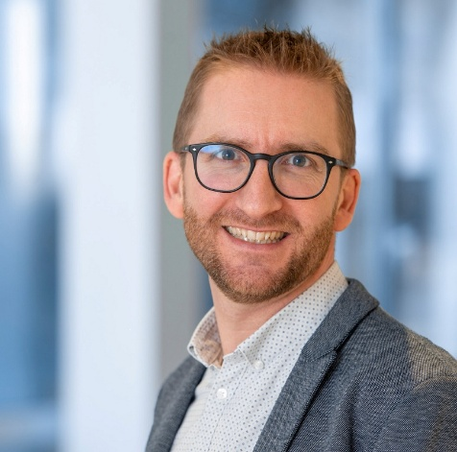

Prof. Raphaël Frédérick is Chemist by training. After a Master in Drug Design awarded from the University of Lille (France), he performed a PhD in Medicinal chemistry at the University of Namur (UNamur, Belgium), which he obtained in 2006. Thereafter, he joined the team of Prof. Sir Bill Denny at the Auckland Cancer Society Research Center (ACSRC) at the University of Auckland, New Zealand for a 2-year postdoc stay. His research project aimed at discovering novel p110α-PI3 kinase inhibitors for cancer therapy, and led to the identification of several novel small molecule inhibitors, some of them having been evaluated in clinical settings. In 2011, he became F.R.S.-FNRS Research Associate at the University of Namur where he pursued his research in the discovery of new drug candidates in the field of anticancer immunotherapy. His research notably led to the discovery of LM10, the first bioavailable, selective tryptophan-2,3-dioxygenase (TDO2) inhibitor that helped establishing the proof-of-concept of TDO2 inhibition for cancer immunotherapy. In 2013, he was recruited as a Professor of organic and medicinal chemistry at the Université catholique de Louvain (UCLouvain) in Brussels, Belgium, where he is heading the lab of Medicinal Chemistry. His team comprises 12 researchers and is active in medicinal chemistry/chemical biology in oncology in two main fields: (1) cancer immunotherapy and (2) tumor metabolism. His strategy involves the discovery and study of novel small molecules targeting enzymes at their active-site, and the development of chemical biology tools to interrogate protein self-assembly in drug design. To date, Prof. Frédérick authored more than 80 peer-reviewed papers and is inventor of 5 patent applications.

